MyFileDrive – (MERN stack web Application)

Introduction
MyFileDrive is a web-based file storage and management system developed using the MERN stack (MongoDB, Express.js, React.js, and Node.js). The system allows users to upload, store, access, download, and manage files such as documents, images, and videos from any location through an internet connection. It provides a centralized platform where users can organize and retrieve their data conveniently without depending on local storage.
The main purpose of this project is to provide a simple, efficient, and secure platform for file storage while demonstrating the practical implementation of modern web technologies. The application ensures that users can perform essential file operations seamlessly through an intuitive user interface. It also incorporates authentication mechanisms to ensure that only authorized users can access their respective files, thereby maintaining data privacy and security.
To handle large files efficiently, the system uses MongoDB GridFS, which divides files into smaller chunks and stores them in the database. This approach overcomes the default size limitations of MongoDB documents and enables smooth uploading and retrieval of larger files such as videos. The backend, built with Node.js and Express.js, manages API requests, handles file operations, and communicates with the database, while the React frontend provides a responsive and interactive user experience.
Additionally, the project focuses on understanding core concepts of full-stack development, including client-server architecture, RESTful API design, database management, and file handling mechanisms. It also highlights the importance of structured code organization, modular design, and efficient data flow between different components of the system.
This project is designed primarily for learning purposes and aims to give practical experience in building real-world applications. It helps in developing a deeper understanding of how file storage systems work internally and prepares a foundation for future enhancements such as cloud integration, file sharing, and advanced access control mechanisms.

Objective
The primary objective of the MyFileDrive project is to design and develop a web-based file storage system that enables users to efficiently store, manage, and access their files from any location. The project focuses on implementing a full-stack application while understanding the core concepts of file handling and database management.
The specific objectives of the project are as follows:
- To develop a robust and scalable file storage application using the MERN stack (MongoDB, Express.js, React.js, and Node.js).
- To enable users to upload, store, download, and delete files in a secure and organized manner.
- To implement user authentication and authorization mechanisms to ensure that only authorized users can access their files.
- To utilize MongoDB GridFS for handling large files by splitting them into smaller chunks, thereby overcoming database size limitations.
- To design a responsive and user-friendly interface that enhances usability and provides a smooth user experience.
- To understand and implement RESTful APIs for communication between the frontend and backend.
- To ensure data consistency and reliability during file storage and retrieval operations.
- To gain practical experience in integrating different technologies within a full-stack environment.
- To build a foundation for future enhancements such as cloud storage integration, file sharing, and advanced security features.
Overall, the objective of this project is not only to build a functional file management system but also to develop a deeper understanding of modern web development practices and system design principles.

Scope of the Project
The scope of the MyFileDrive project is to develop a web-based application that provides users with a centralized platform to store and manage their files online. The system is designed to support basic file management operations such as uploading, viewing, downloading, and deleting files. It allows users to access their data from any location using an internet connection, making file storage more flexible and convenient compared to traditional local storage methods.
The project primarily focuses on implementing core functionalities of a file storage system using the MERN stack. It includes user authentication to ensure secure access, and MongoDB GridFS is used for efficient storage and retrieval of large files. The application is intended to handle different types of files such as documents, images, and videos within a manageable size range suitable for a learning environment.
The scope of the project is limited to a single-user file management system where each user can manage their own files independently. Advanced features such as real-time collaboration, distributed storage, cloud-based content delivery networks (CDN), and large-scale scalability are not included in this version of the project. However, the system is designed in a way that these features can be added in the future.
Additionally, the project emphasizes learning and understanding full-stack development concepts, including frontend-backend communication, API design, database management, authentication, and file handling mechanisms. It serves as a foundational system that can be extended and improved with more advanced features in future iterations.

Functional Requirements
Functional requirements define the core features and operations that the MyFileDrive system must perform. These requirements describe how the system should behave and the services it must provide to users.
The functional requirements of the system are as follows:

1. User Authentication (Google OAuth)
- The system allows users to log in using their Google account.
- Authentication is implemented using Passport.js using the Google OAuth 2.0 strategy.
- Users are redirected to Google’s login page for secure authentication.
- After successful login, the system retrieves user profile information.
- New users are automatically registered in the system on first login.
- The system ensures that only authenticated users can access file-related features.

2. File Upload
- Users should be able to upload files such as documents, images, and videos.
- The system should accept different file formats within a defined size limit.
- Files should be stored using MongoDB GridFS.
- Large files should be handled efficiently by splitting them into smaller chunks.

3. File Viewing
- Users should be able to view a list of all uploaded files.
- The system should display file details such as filename, size, type, and upload date.
- Files should be displayed in an organized and user-friendly format.

4. File Download
- Users should be able to download their stored files.
- The system should retrieve files from GridFS and stream them to the user.
- The download process should maintain file integrity.

5. File Deletion
- Users should be able to delete their files.
- The system should remove both file metadata and corresponding chunks from the database.
- Deleted files should no longer be accessible.

6. User-Specific File Access
- Each user should only be able to access their own files.
- The system should enforce authorization checks before allowing file operations.
- Unauthorized access attempts should be restricted.

7. Session Management
- The system should maintain user sessions after successful login.
- Users should remain authenticated until they log out or the session expires.

8. Error Handling
- The system should handle errors such as failed authentication, file upload errors, and missing files.
- Appropriate error messages should be displayed to guide the user.

9. Logout Functionality
- The system should allow users to securely log out.
- User sessions should be terminated after logout.

Database Design
The MyFileDrive system uses MongoDB Atlas as the database to store user information and file data. Since the application deals with large files such as images and videos, MongoDB GridFS is used for efficient file storage and retrieval. GridFS allows files to be stored by dividing them into smaller chunks, overcoming the default 16MB document size limitation of MongoDB.

1. User Collection
This collection stores information about authenticated users.
Fields:
- userId – Unique identifier for each user
- googleId – Unique ID provided by Google OAuth
- name – User’s name
- email – User’s email address
- profilePicture – URL of user’s profile image (optional)
- createdAt – Account creation timestamp

2. File Storage using GridFS
GridFS stores files in two separate collections:

a. files Collection
This collection stores file metadata.
Fields:
- fileId – Unique identifier for the file
- filename – Name of the uploaded file
- contentType – Type of file (image, video, document, etc.)
- length – Size of the file
- uploadDate – Date and time of upload
- userId – Reference to the user who uploaded the file

b. chunks Collection
This collection stores the actual file data in smaller parts.
Fields:
- chunkId – Unique identifier for each chunk
- files_id – Reference to the file in the files collection
- n – Sequence number of the chunk
- data – Binary data of the chunk
When a file is uploaded:
- The file is divided into smaller chunks.
- Each chunk is stored in the chunks collection.
- File metadata is stored in the files collection.
When a file is requested:
- The system retrieves all chunks related to the file.
- Chunks are combined in order.
- The file is streamed back to the user.

3. Database Relationships
- Each user can upload multiple files (One-to-Many relationship).
- Each file belongs to a single user.
- Each file is associated with multiple chunks in GridFS.

4. Advantages of Using GridFS
- Allows storage of large files beyond 16MB
- Efficient file retrieval using streaming
- Automatic handling of file chunking
- Suitable for learning file storage mechanisms

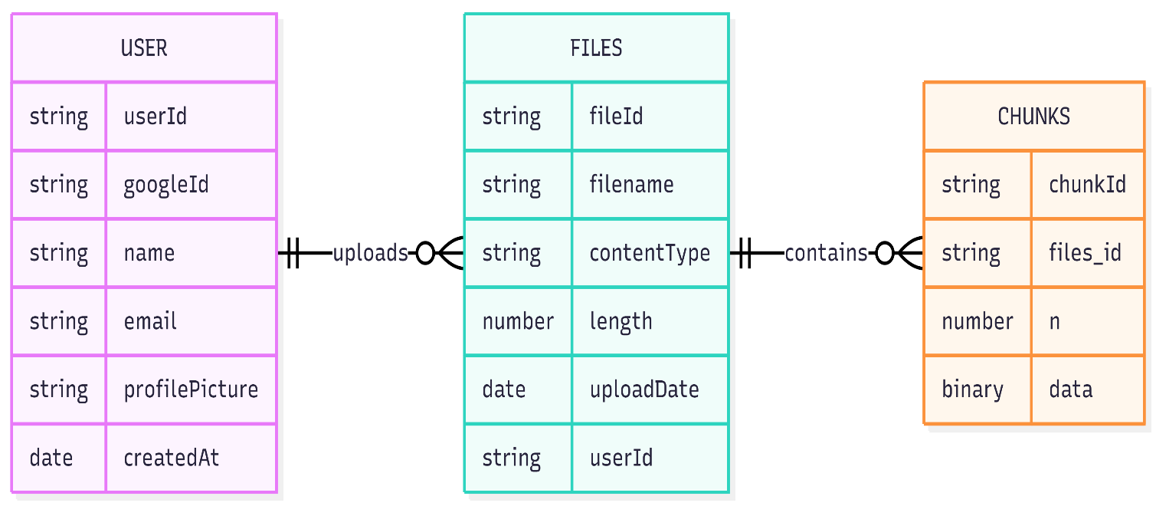
Figure: Entity-Relationship (ER) Diagram of MyFileDrive Database

System Workflow
The system workflow of MyFileDrive describes how different components of the application interact to perform various operations such as authentication, file upload, file retrieval, and file deletion. It explains the flow of data between the frontend, backend, and database.

1. User Authentication Workflow (Google OAuth)
- The user clicks on “Login with Google” on the frontend.
- The request is sent to the backend.
- Passport.js redirects the user to Google’s authentication page.
- The user logs in using their Google account.
- Google sends user information back to the backend.
- The backend verifies the user and creates or retrieves the user record from the database.
- A session or token is generated and sent to the frontend.
- The user is granted access to the system.

2. File Upload Workflow
- The user selects a file from the frontend interface.
- The file is sent to the backend using an HTTP request.
- The backend processes the file using middleware (multer).
- The file is stored in MongoDB using GridFS.
- GridFS splits the file into chunks and stores them in the database.
- File metadata is saved in the files collection.
- A success response is sent back to the frontend.

3. File Retrieval / Download Workflow
- The user requests to download a file.
- The frontend sends a request to the backend with the file identifier.
- The backend retrieves file metadata from the database.
- GridFS fetches all related chunks.
- The chunks are combined and streamed to the user.
- The file is downloaded on the user’s device.

4. File Deletion Workflow
- The user selects a file to delete.
- The frontend sends a delete request to the backend.
- The backend verifies user authorization.
- The file metadata and associated chunks are removed from the database.
- A confirmation response is sent to the user.

5. Overall System Flow
- The frontend interacts with the user and sends requests.
- The backend processes requests and manages logic.
- MongoDB stores user data and files using GridFS.
This workflow ensures smooth communication between all components and enables efficient file management operations.

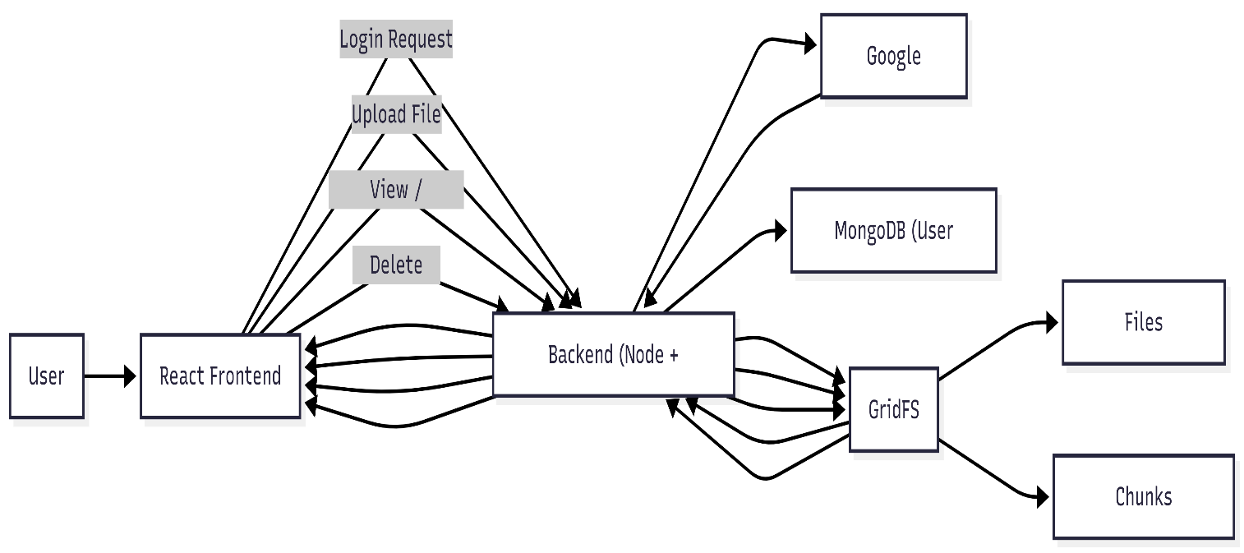

Figure: System Workflow Diagram of MyFileDrive

Advantages and Limitations

Advantages
- The system provides a centralized platform for storing and managing files.
- Users can access their files from anywhere using an internet connection.
- MongoDB GridFS allows efficient handling of large files by splitting them into smaller chunks.
- Google OAuth authentication simplifies login and enhances security by avoiding password management.
- The MERN stack enables fast development and smooth communication between frontend and backend.
- The application has a simple and user-friendly interface.

Limitations
- MongoDB is not optimized for large-scale file storage compared to cloud storage solutions.
- Performance may decrease when handling very large files or a high number of users.
- The system does not include advanced features like file sharing or collaboration.
- No integration with content delivery networks (CDN) for faster file access.
- Limited scalability for production-level usage.

Future Enhancements
- Integration with cloud storage services such as AWS S3 or Cloudinary.
- Implementation of file sharing through public or private links.
- Addition of folder structure for better file organization.
- Support for file preview (images, videos, documents).
- Implementation of drag-and-drop file upload.
- Addition of file size limits and upload progress indicators.
- Improved UI/UX for better user experience.

Conclusion
The MyFileDrive project successfully demonstrates the development of a web-based file storage and management system using the MERN stack. It provides essential functionalities such as file upload, download, viewing, and deletion, along with user authentication using Google OAuth.
The project helped in understanding important concepts such as full-stack development, RESTful APIs, database design, and file handling using MongoDB GridFS. It also highlights the interaction between frontend, backend, and database components in a real-world application.
Although the system has certain limitations, it serves as a strong foundation for building more advanced and scalable file storage solutions in the future.

